“LEGAL DOCUMENT REPOSITORY”

Project Report submitted for the partial fulfilment of grade for the course

Data Structures and Algorithms -3 (25CS2103E)

in

DEPARTMENT OF COMPUTER SCIENCE ENGINEERING

by

ALLURU AKSHAYA :250030189

YASAAM BHAARATHI :250030211

CHADA HASIKA :250030372

Team Number:12
Section:8

Under the Guidance of

Dr. V. Sireesha
Associate Professor
Department of Computer Science and Engineering





2026-27

DEPARTMENT OF COMPUTER SCIENCE ENGINEERING

Declaration

The Project Report entitled “Legal Document Repository” is a record of Bonafide work of ALLURU AKSHAYA – 250030189, YASAM BHAARATHI– 250030211, CHADA HASIKA– 2520030272 submitted in partial fulfillment for the award of B. Tech in Computer Science and Engineering. The results embodied in this report have not been copied from any other departments/University/Institute.

ALLURU AKSHAYA – 250030189
YASAM BHAARATHI– 250030211
CHADA HASIKA– 2520030272

DEPARTMENT OF COMPUTER SCIENCE ENGINEERING

CERTIFICATE

This is certified that the mini project-based report entitled “Legal Document Repository” is a bonafide work done and submitted by Alluru Akshaya-2520030189, Yasam Bhaarathi-2520030211, Chada Hasika-2520030272 in partial fulfillment of the requirements for the award of the degree of BACHELOR OF TECHNOLOGY in Department of Computer Science Engineering, during the academic year 2026-27.

Signature of the Guide Signature of the HOD
(Dr.V. Sireesha)

Signature of the External Examiner
ACKNOWLEDGEMENT

Description in Times New Roman font 12 size with two to three paragraphs thanking guide Dr. V. Sireesha , Associate Professor, Dept. of CSE and Dr. P. Venkateshwara Rao, Associate Professor, HOD CSE

ALLURU AKSHAYA – 250030189
YASAM BHAARATHI– 250030211
CHADA HASIKA– 2520030272

Abstract

In the digital era, managing and retrieving legal documents efficiently has become an important task. Legal documents such as judgments, case records, contracts, agreements, and legal notices contain valuable information that may be difficult to locate when stored across multiple files. Manual searching requires considerable time and effort, especially when the exact document name or search term is unknown. To address this problem, LexFind – Legal Document Repository is developed as a Java-based academic project that combines document organization with efficient text-searching algorithms.
The main objective of LexFind is to provide a structured system for loading, accessing, searching, and comparing text-based legal documents. The system organizes available documents and their metadata, allowing users to locate relevant information more easily. It incorporates string-matching algorithms such as Knuth–Morris–Pratt (KMP), the Z-algorithm, and Rabin–Karp for exact pattern searching. Dynamic programming and edit distance are used for approximate matching, helping identify possible matches when search terms contain spelling differences. The Aho–Corasick algorithm supports multiple-keyword searching, while suffix arrays and Longest Common Prefix (LCP) techniques support the identification of common text between documents.
The application follows a modular design that separates document handling, repository management, algorithm processing, and user interaction. This structure improves maintainability and makes it easier to test the implemented search operations. LexFind provides a practical application of Data Structures and Algorithms concepts, including string processing, dynamic programming, and complexity analysis, while strengthening Java programming and software development skills.
The current project focuses on searching and comparing text within the supported local document collection. It is an academic prototype and does not provide legal advice or determine the legal validity of documents. Future enhancements may include database integration, improved search ranking, semantic search, and enhanced security features. Overall, LexFind demonstrates how algorithmic techniques can make legal document retrieval more organized, efficient, and accessible.

Keywords: LexFind, Legal Document Repository, String Matching, KMP, Rabin–Karp, Aho–Corasick, Dynamic Programming, Edit Distance, Suffix Array.

Table of Contents
S.No | Contents | Subtopics | Page. No
 | Acknowledgement |  | 4
 | Abstract |  | 6
 | Table of Contents |  | 7
 | List of Figures |  | 8
1 | Introduction | - Overview  - Problem Statement  - Scope of the Project  - Objectives | 9–18
2 | System Requirements | 2.1 Functional Requirements  2.2 Non-Functional Requirements | 18–20
3 | System Design | 3.1 High-Level Architecture Diagram  3.2 Description of Each Layer | 20–22
4 | Implementation | 4.1 Module-Wise Implementation  4.2 Front-End Logic (UI Rendering, State Management)  4.3 API Integration  4.4 … | 22–26
5 | Results |  | 26–28
6 | Challenges & Limitations | 6.1 Issues Faced During Development  6.2 Solutions Applied  6.3 Limitations of the System | 28–31
7 | Conclusion & Future Work | 7.1 Conclusion  7.2 Future Work  7.3 Skills Learned During Development used | 31–34

List of Figures
Figure No. | Figure Title | Page No.
Figure 1.1 | Block Diagram of LEXFIND | 9
Figure 1.2 | Components of LEXFIND | 11
Figure 1.3 | Flowchart Showing the Working of LEXFIND | 12
Figure 1.4 | Phases of LEXFIND | 14
Figure 1.5 | Keyword Search and Fuzzy Search in LEXFIND | 16
Figure 1.6 | Multi-Keyword Search and Document Similarity in LEXFIND | 17

- INTRODUCTION

1.1 Introduction to the System Architecture
LEXFIND (Legal Document Repository) is a Java-based application developed to organize, search, and retrieve legal documents efficiently. The system provides a menu-driven terminal interface through which users can perform various operations on a collection of fictional legal case records. Each record contains information such as the case title, plaintiff, defendant, document type, keywords, and document content.
The main purpose of LEXFIND is to demonstrate how data structures, string-processing techniques, and search algorithms can be applied to legal information retrieval. Instead of requiring users to examine every document manually, the application provides search functionalities that help locate records based on user-specified terms and document content.
The system supports several operations, including keyword search, fuzzy search using edit distance, multi-keyword search, document similarity analysis, viewing document details, adding new records, listing available documents, and displaying repository statistics. These features are accessed through a terminal menu, making the application straightforward to operate and suitable for demonstrating algorithmic concepts.
The architecture of LEXFIND separates user interaction, application processing, document management, and search operations at a logical level. When a user selects an operation, the application processes the request, examines the available records using the corresponding functionality, and displays the result in the terminal.
This structured approach makes the system easier to understand, test, maintain, and extend. It also provides a practical demonstration of how multiple algorithms can be integrated into one application to solve different types of document retrieval problems.
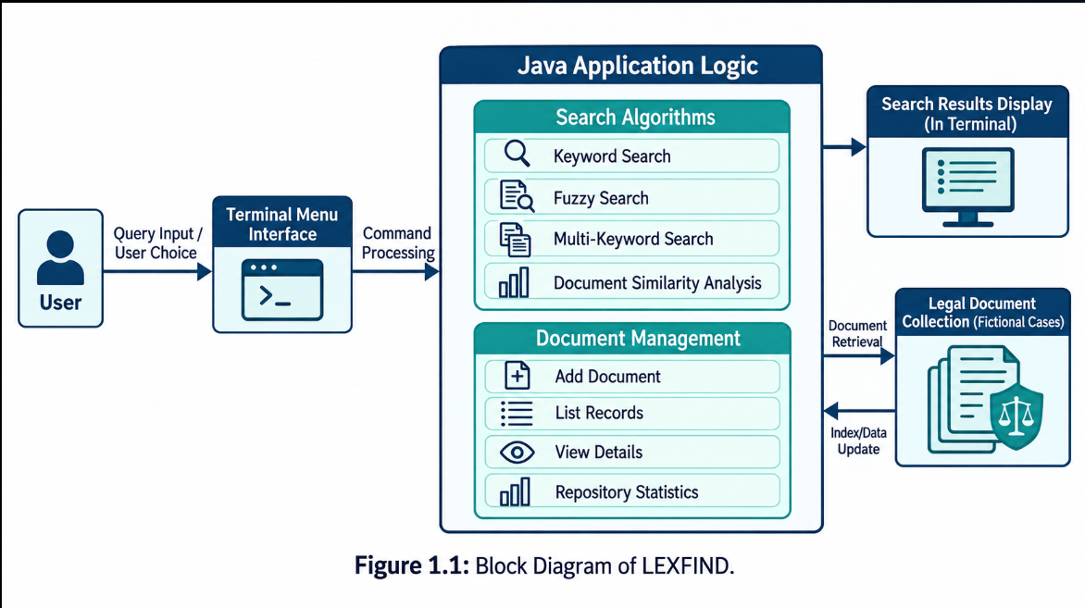 1.2 Components of LEXFIND
LEXFIND consists of several functional components that work together to provide legal document management and retrieval facilities. Each component is responsible for a specific operation, allowing the application to support different user requirements through a single menu-driven interface.
The components are described below.
- Terminal User Interface
The terminal user interface acts as the interaction point between the user and the application. When the program starts, it displays the LEXFIND title and a menu containing the available operations. The user selects an option and provides the required input, such as a keyword, search phrase, or document details. The application then processes the selected operation and displays the corresponding output in the terminal.
- Legal Document Collection
The legal document collection contains the fictional legal records used by the application. Each record stores relevant information, including the case title, plaintiff, defendant, document type, keywords, and content. These fields allow users to search for cases using different types of information. The collection acts as the primary source of records for searching, displaying details, and generating repository statistics.
- Keyword Search Module
The keyword search module enables users to locate legal documents by entering a relevant term. The application compares the query with the searchable information in the available records and returns documents that satisfy its matching conditions. This feature is useful when users know a specific word or phrase associated with the required case.
- Fuzzy Search Module
The fuzzy search module supports approximate string matching. It uses edit distance to measure the difference between strings by considering operations such as insertion, deletion, and substitution of characters. This technique can help identify relevant terms when a user enters a misspelled or slightly different query. For example, a search for contrct may match contract if the algorithm's matching conditions permit it.
- Multi-Keyword Search Module
The multi-keyword search module allows users to provide multiple search terms to locate relevant legal records. Instead of searching using only one word, users can supply several terms associated with a case. The application evaluates the terms according to its implemented matching logic and displays the matching records.

- Document Similarity Module
The document similarity module compares legal records to identify documents that share similar characteristics. Depending on the implemented algorithm, the comparison may use document content, keywords, or other textual information. This functionality helps demonstrate how text comparison techniques can be used to identify related records within a legal document collection.
- Document Management Module
The document management module supports operations such as adding new legal records, listing available documents, and viewing individual document details. When a new record is added, the application collects the required fields and incorporates the record into the repository according to its implementation. Users can also examine the information associated with an existing case.
- Repository Statistics Module
The repository statistics module provides an overview of the available legal document collection. It may display information such as the total number of documents or other statistics calculated by the application. This feature helps users understand the size and basic composition of the repository.
These components work together to make LEXFIND a unified legal document retrieval application. Each search operation serves a different purpose, while the document management functions allow users to examine and maintain the collection.
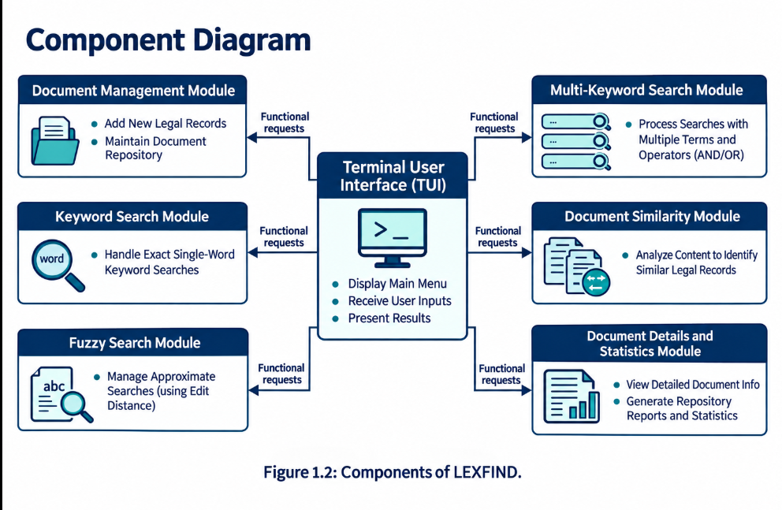
The component diagram should follow the explanation of the modules so that readers can visually understand how the different parts of the application are organized.

1.3 Working of LEXFIND
The working of LEXFIND follows a menu-driven execution process. The application begins by initializing the legal document collection and preparing the available operations. After initialization, the main menu is displayed in the terminal, allowing users to choose the required functionality.
When a user selects an operation, the application accepts the necessary input. For example, keyword search requires a search term, fuzzy search requires a query for approximate matching, and document similarity analysis requires the input expected by the implemented comparison procedure.
The selected operation is then executed using the corresponding processing logic. The application examines the available legal records and identifies matching documents or generates the requested information. In the case of document management operations, the program may collect new record details, display an existing record, or list the available documents.
After the selected operation is completed, the application presents the result in the terminal. The user can then select another operation from the menu without restarting the application. This process continues until the user chooses the exit option.
The menu-driven approach makes the application easy to navigate and provides a consistent interaction pattern for all supported functionalities. It also allows different search algorithms to be demonstrated through a common interface.
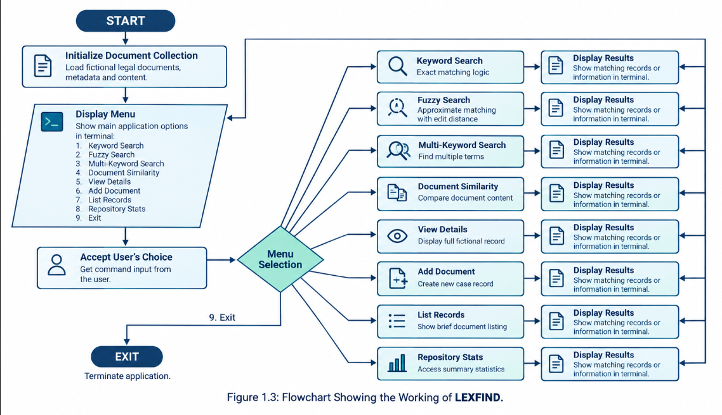
The flowchart should illustrate the complete sequence, from starting the application and loading the records to selecting an operation, processing the request, displaying results, and returning to the menu or exiting.
1.4 Operational Phases of LEXFIND
The operational phases of LEXFIND describe how the system progresses from preparing the legal records to displaying the requested information. These phases explain the logical sequence of processing performed by the application.
Phase 1: Legal Document Collection
The process begins with a collection of fictional legal documents. These records provide sample information for testing and demonstrating the search functionalities. The collection may include different types of legal cases, keywords, parties, and document content.
Phase 2: Document Structuring
Each document is organized using fields such as case title, plaintiff, defendant, document type, keywords, and content. Structuring the information allows the application to access and display individual records consistently.
Phase 3: Repository Initialization
When the application starts, the available records are initialized or loaded according to the program's implementation. The application prepares the collection for subsequent search, retrieval, and document management operations.
Phase 4: User Query Input
The user selects an operation from the terminal menu and enters the required information. The input may be a keyword, a phrase, multiple search terms, or another value required by the selected operation.
Phase 5: Algorithm Execution
The application processes the input using the selected search or comparison technique. Keyword search checks for matching terms, fuzzy search compares strings using edit distance, multi-keyword search evaluates multiple terms, and document similarity analysis compares records using the implemented method.
Phase 6: Matching and Retrieval
The application identifies the records or information that satisfy the selected operation's conditions. The exact matching and comparison behaviour depends on the algorithm implemented for that operation.

Phase 7: Result Presentation
Finally, the application displays the matching records, document details, or requested statistics in the terminal. The user can review the result and continue using another menu option.
Together, these phases explain how LEXFIND converts user input into meaningful document retrieval results. They also show how document organization and algorithm execution contribute to the overall functioning of the application.
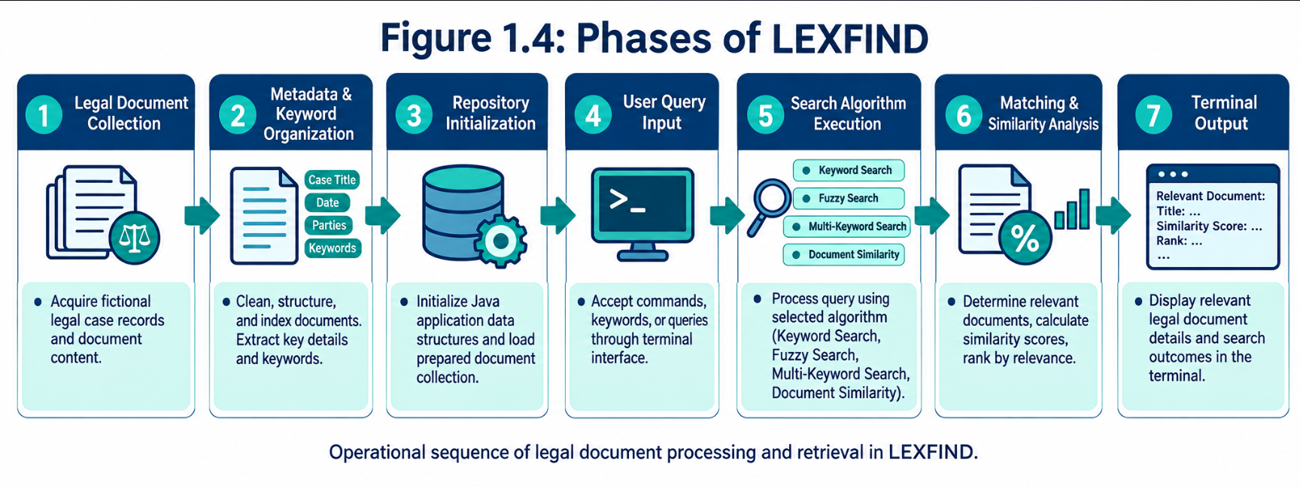
Place the phases diagram after the seven-phase explanation. This allows the reader to connect the written description with the visual representation of the processing sequence.
1.5 Keyword Search and Fuzzy Search in LEXFIND
Searching is one of the primary functions of LEXFIND. A legal document collection may contain numerous records, and manually examining every record to locate a particular case can be time-consuming. Search algorithms help reduce this effort by identifying records based on the user's query.
LEXFIND includes keyword search and fuzzy search to demonstrate two different approaches to retrieving relevant legal information.
1.5.1 Keyword Search
Keyword search allows users to locate legal records by entering a relevant word or phrase. The application compares the provided query against the searchable information in its document collection and displays records that satisfy the implemented matching conditions.
For example, a user may search for the keyword contract to locate fictional legal records associated with contract disputes. If the term appears in the searchable fields of a record, that record may be returned as a result.
Keyword search is useful when users already know the terminology associated with the required document. It provides a direct method of locating relevant records without requiring users to inspect the entire collection manually.
The effectiveness of keyword search depends on the matching rules used by the application. Exact matching, partial matching, case normalization, and the fields examined during a search should be described according to the actual Java implementation.
1.5.2 Fuzzy Search Using Edit Distance
Fuzzy search is used to identify approximate matches between a user query and text available in the document collection. Unlike a strictly exact-match approach, fuzzy search can account for certain differences between strings.
LEXFIND uses edit distance as the basis of its fuzzy-search functionality. Edit distance measures the minimum number of character-level operations needed to transform one string into another. The standard Levenshtein edit distance considers three operations:
- Insertion: Adding a character to a string.
- Deletion: Removing a character from a string.
- Substitution: Replacing one character with another.
Consider the words contract and contrct. The second word is missing the letter a. Under standard Levenshtein distance, transforming contrct into contract requires one insertion, so their edit distance is 1.
This allows the application to identify a possible match when the query contains a minor spelling error, provided the implemented matching threshold accepts that distance.
Fuzzy search can be useful when users do not remember the exact spelling of a legal term or enter a query containing typographical errors. However, approximate matches should be interpreted carefully because similar strings do not necessarily represent identical legal concepts.
1.5.3 Importance of Combining Both Search Methods
Keyword search and fuzzy search address different user needs. Keyword search provides direct retrieval based on the application's matching rules, while fuzzy search can identify approximate textual matches.
Combining these functionalities gives users alternative ways to search the legal document collection. The two methods demonstrate how string-processing algorithms can improve the flexibility of information retrieval within LEXFIND.
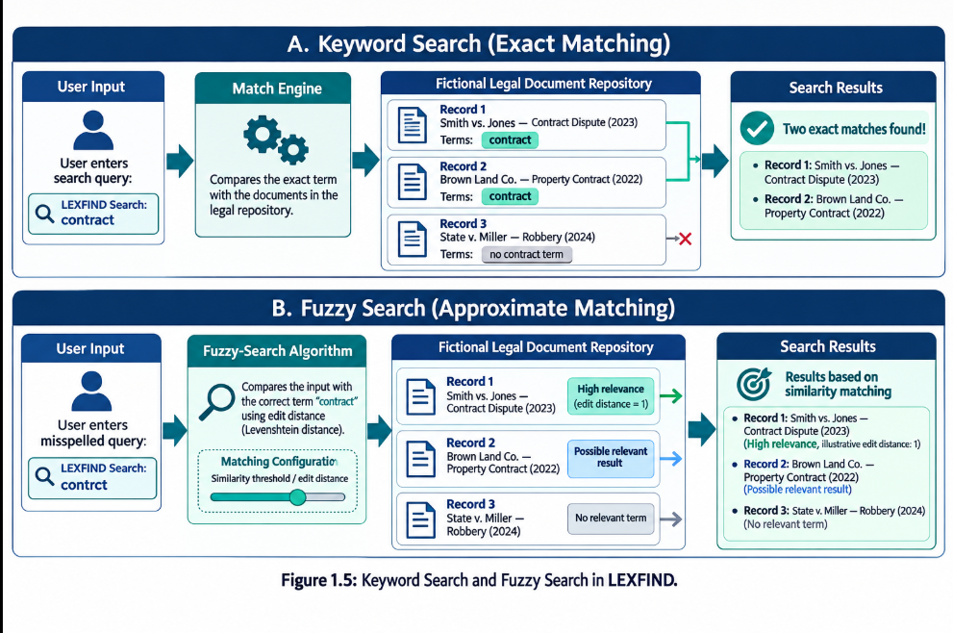Place the diagram after explaining both techniques. The image should visually compare ordinary keyword matching with edit-distance-based approximate matching, using a clearly labelled example.
1.6 Multi-Keyword Search and Document Similarity in LEXFIND
In addition to searching with individual terms, LEXFIND provides functionality for processing multiple keywords and identifying similar legal documents. These capabilities demonstrate how document retrieval can use more than a single search term or an exact textual match.
1.6.1 Multi-Keyword Search
Multi-keyword search enables users to search for legal records using several terms associated with a particular case. Legal documents frequently discuss multiple subjects, parties, or events, so a single keyword may not always provide enough information to identify the required record.
For example, a user may search for terms such as contract, payment, and dispute when looking for fictional cases associated with contractual payment disagreements. The application processes the supplied terms according to its implemented search logic and returns the records that meet the matching conditions.
This approach allows users to express a more specific information need than a search based on one word alone. It can also help distinguish records that share a general topic but differ in their content.
The exact behavior of multi-keyword search depends on how the Java program evaluates the supplied terms. For example, the implementation may require all specified terms, accept any matching term, or use another matching rule. The report should state the rule used by the actual program rather than assume that it implements Boolean AND/OR logic.
1.6.2 Document Similarity Analysis
Document similarity analysis is used to identify legal records that share textual characteristics. Instead of relying only on a user-supplied keyword, this functionality compares documents using the information and comparison technique supported by the application.
For example, two fictional legal records may both discuss contract disputes and payment obligations. If their content or keywords overlap sufficiently according to the implemented similarity method, the application may identify them as similar documents.
The similarity calculation depends on the algorithm used in LEXFIND. Different techniques may compare shared words, textual features, or other representations of the records. The similarity value, if displayed, must be interpreted according to the particular metric used.
Document similarity is useful for exploring related records, comparing legal cases, and discovering documents that contain comparable information. However, textual similarity alone does not establish that two cases have the same legal outcome or meaning.
1.6.3 Role in Legal Information Retrieval
Multi-keyword search and document similarity serve complementary purposes. Multi-keyword search locates documents based on the terms supplied by the user, whereas document similarity identifies relationships between records based on the implemented comparison method.
Together, these functionalities demonstrate how different algorithmic approaches can be integrated into a single legal document repository. They extend the ways users can explore the fictional legal records and illustrate the practical use of text-processing techniques in information retrieval.
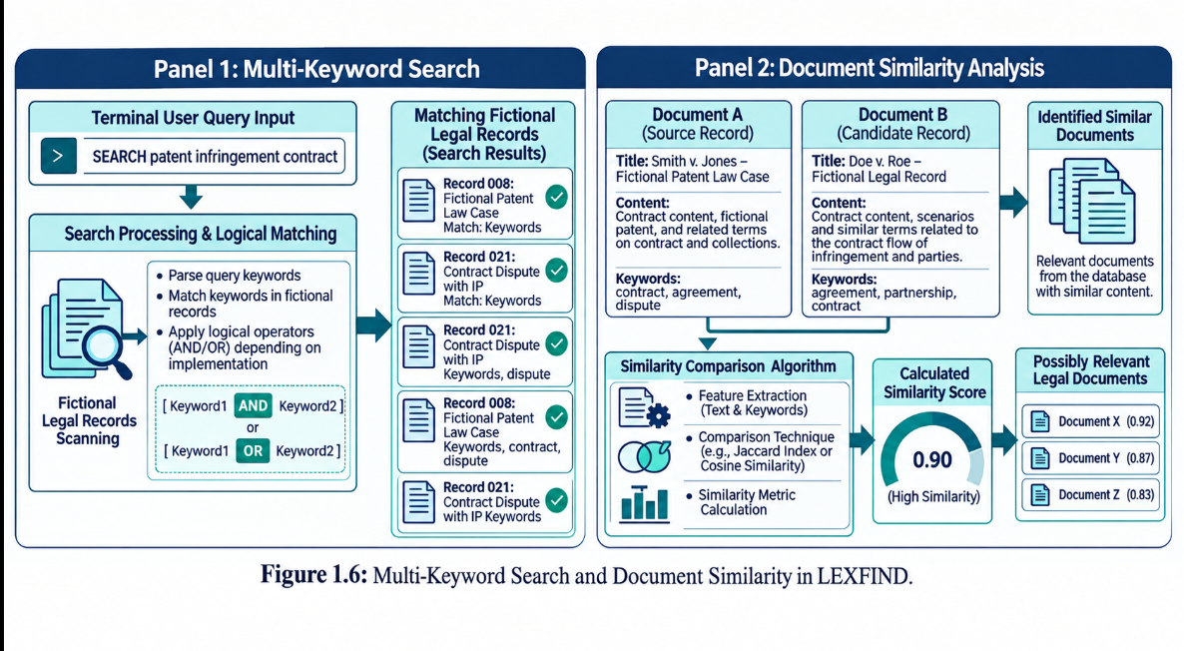
The diagram should contain two clearly separated panels: one showing the processing of multiple search terms and the other illustrating the comparison of two legal records. If an example similarity score is included, identify it as illustrative unless it was generated by your actual application.

SYSTEM REQUIREMENTS

2.1 Functional Requirements

Functional requirements describe what the repository must do when a user interacts with it. The application should load the supported text files from the configured corpus location and make the records available through a central repository component. If a file cannot be read, the program should report the problem clearly and continue where safe rather than failing without explanation.
The user should be able to browse or list the loaded documents and inspect the details available for a selected record. Each record should have an identifier that can be used to retrieve it. Descriptive fields may include title, case number, date, category, parties, court, status, keywords, and content, depending on the source file.
The search functions should accept a query and return records whose text satisfies the selected search operation. Exact search should locate the specified pattern. Fuzzy search should compare candidate text using a documented edit-distance threshold. Multi-keyword search should process a group of terms and report which records contain them. Document comparison should compare a selected record with other records using the implemented common-text method.
The application should validate user input before calling the algorithms. An empty query should not be treated as a valid search pattern unless the implementation explicitly defines that behavior. An invalid menu selection should produce a helpful message. An unknown document ID should not crash the application. When no match is found, the result should state that clearly rather than presenting a blank output.
The application should present results in a consistent format. Each result should identify the document, show available descriptive fields, and state which operation produced the result when that distinction is useful. If counts or similarity values are shown, the interface should explain what is counted or measured. The output should not imply that a fuzzy match or shared passage proves semantic or legal equivalence.
The repository should keep file loading, document lookup, and search processing separate from the menu logic. This allows the application to reuse the same loaded records across
operations and helps developers test individual modules. Any add, update, delete, or save operation should only be documented as available if it is present in the final integrated code.
Software | Purpose
Java Development Kit (JDK) | Compiling and running the application
IDE or text editor | Writing and debugging Java code
Operating system | Running the application
Text corpus | Providing legal-style documents for searching

2.2 Non-Functional Requirements

Usability is an important non-functional requirement because the project is intended to be demonstrated to users who may not know the names of the algorithms. Menu options and messages should describe tasks in plain language. For example, the interface should use labels such as exact search, fuzzy search, search multiple keywords, and compare documents rather than exposing internal course labels as the primary navigation.
Correctness requires the same input and corpus to produce consistent results under the same configuration. The application should use a clear rule for case sensitivity and text normalization. If the query and document are converted to lowercase before matching, this should be applied consistently. The program should also avoid silently changing the meaning of the text while preparing it for search.
Performance should be appropriate for the size of the educational corpus. The selected algorithms have different time and memory costs, and those costs depend on text length, pattern length, number of patterns, and number of documents. Complexity analysis should identify these variables. A small test corpus can demonstrate functionality, but it cannot alone establish performance on a large institutional archive.
Maintainability requires readable Java code, meaningful class and method names, clear module boundaries, and limited duplication. Error handling should be consistent. Constants such as file extensions, menu options, and matching thresholds should be easy to locate and revise. Documentation should describe the implementation that exists rather than a hypothetical version.

Portability depends on using a supported Java Development Kit and avoiding assumptions about a single machine's file paths. Corpus locations should be configurable or clearly documented. Text should be read with an explicit character encoding where possible so that special characters are handled predictably.
Reliability means the program should handle empty corpora, unreadable files, unknown identifiers, empty queries, repeated delimiters, and other expected edge cases gracefully. Security is limited in the educational prototype, especially if documents are sensitive. Real deployment would require controlled access, secure storage, audit trails, and data-handling policies that are outside the current project scope.
The hardware requirement is modest for a small local text corpus: a standard computer capable of running the chosen Java runtime, with sufficient memory for the loaded text and temporary algorithm data. The software requirement is a compatible JDK, an IDE or command-line compiler, the project source files, and the text corpus used for testing. Exact versions and operating-system details should be recorded from the actual development environment.

SYSTEM DESIGN

High-Level Architecture Diagram
The high-level design separates the application into a presentation layer, a repository and document-model layer, and an algorithm-processing layer. The presentation layer receives user input and displays results. The repository layer loads the corpus and provides access to individual records. The algorithm layer performs the requested search or comparison operation and returns a result that the presentation layer can format.
This separation is useful because the user interface should not need to know the internal steps of KMP, edit distance, Aho–Corasick, or suffix-array processing. It only needs to validate the user's choice, pass the required text to the appropriate module, and present the returned result. Likewise, algorithm modules should not be responsible for printing menu prompts or reading files from the console.
The document model represents the information associated with a record. It can include an identifier and descriptive metadata together with searchable text. The repository acts as the access point for the loaded records, allowing the rest of the program to locate a document or iterate over the collection without duplicating file-reading logic.
The architecture also makes testing easier. A search algorithm can be tested with short strings independently of the full application. Repository loading can be tested with a small directory containing known files. The user interface can be tested with valid and invalid choices. Testing each responsibility separately helps distinguish algorithmic errors from parsing, input, or presentation errors.

3.2 Description of Each Layer
The presentation layer is responsible for interaction with the user. It displays available actions, reads a selected operation and its inputs, validates the input where necessary, invokes the appropriate application function, and formats the returned information. Clear prompts are important because a user should know whether the program expects a document ID, a search phrase, a comma-separated set of keywords, or a selection of two documents.
The repository and document-model layer is responsible for representing and accessing the corpus. The loader reads supported files, creates document records, and stores them in a collection that can be searched by identifier or traversed for document-wide operations. The model keeps the metadata and searchable content associated with each record. Missing values should be handled safely and consistently.
The algorithm layer contains methods that operate on strings or groups of strings. Exact pattern matching may use KMP, Z, or Rabin–Karp. Multi-pattern matching may use Aho–Corasick. Fuzzy matching uses dynamic programming to calculate edit distance. Document comparison may use suffix-array and LCP information to estimate shared text. Each algorithm has different assumptions and complexity, so the caller should select a method that fits the requested task.
The integration flow begins when a user chooses an operation. The presentation layer validates the input and obtains the relevant document text from the repository. It calls the algorithm module with the query or selected records. The algorithm returns matches, distances, counts, or comparison information. The application then associates the result with document metadata and presents it in a consistent format.
Keeping these layers separate improves maintainability. If the user interface changes, the search algorithm need not change. If a more efficient matching method is added later, it can be integrated behind the same operation interface. If the repository moves from local files to persistent storage in future work, the model and access contract can be preserved while the loading implementation changes.

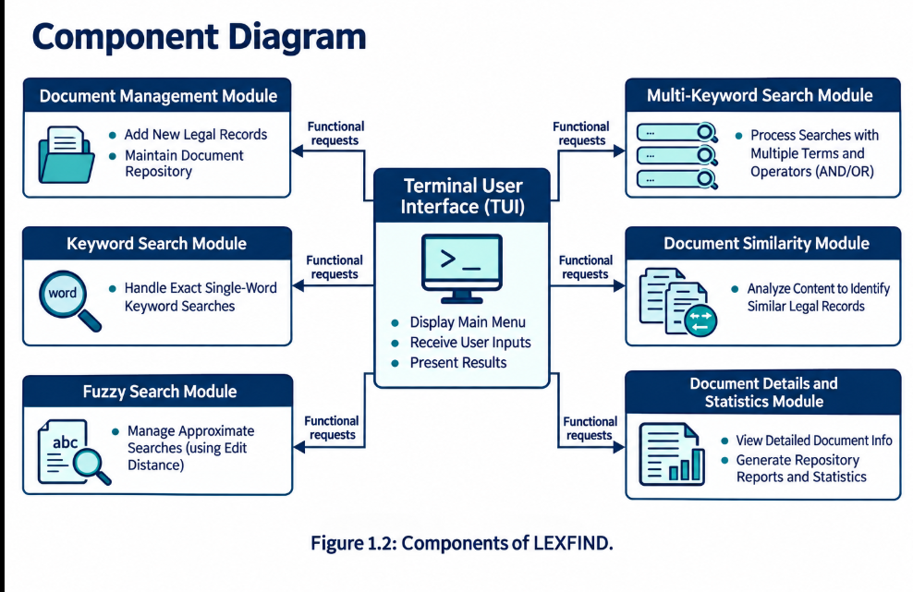

IMPLEMENTATION

4.1 Module-Wise Implementation
The implementation is organized around the main responsibilities of the application: loading the corpus, representing documents, locating records, running search algorithms, comparing documents, and presenting results. The central application class coordinates the menu and dispatches the selected operation. The corpus loader reads the available text files in a predictable order so that demonstration output is repeatable.
The document model stores the fields that identify and describe a record. Searchable text is kept available to the matching routines. Metadata parsing must tolerate fields that are absent or arranged differently between files. The implementation should not reject an otherwise readable document only because an optional field is missing. Instead, it should use a clear fallback for display and keep the document content available for searching.
Exact search is implemented through string-matching routines. KMP preprocesses the pattern to build a prefix table, allowing the search to avoid rechecking characters that are already known to match. The Z-algorithm computes prefix-match lengths over a combined pattern and text representation. Rabin–Karp uses rolling hash values to identify candidate alignments and should verify matches where hash collisions are possible. The algorithms answer the same general question but use different internal strategies.
Fuzzy search uses dynamic programming to calculate edit distance between strings. The distance represents the minimum number of allowed edits needed to transform one string into another under the chosen model. A threshold can be used to filter candidate terms, but the threshold must be selected carefully: a value that is too small can miss useful candidates, while a value that is too large can return unrelated words. The output should be treated as a retrieval aid.
Multi-keyword search can use Aho–Corasick, which builds a trie for the set of patterns and adds failure links. After preprocessing, the text is scanned while the automaton tracks the longest relevant pattern prefix. This method is useful when several keywords are checked against the same document. The program should define whether it reports individual occurrences, unique terms, or documents containing at least one term.
Document comparison can use suffix-array and longest-common-prefix information to find common substrings. A suffix array orders suffixes of a text, while LCP values describe the length of shared prefixes between adjacent suffixes. For comparing two records, the implementation must distinguish the text from each source and use separators carefully so that a match does not incorrectly cross a document boundary. The resulting overlap is a textual indicator rather than a semantic judgment.
The repository access methods allow the application to find a record by ID and to iterate over loaded records for search. If modification operations are present, they should validate identifiers and keep the in-memory collection consistent. If changes are not saved to disk or a database, the interface and report must not imply that they persist after the application exits.
Each module should define its input and output clearly. A matching routine receives a text and a pattern and returns positions or a match indication. A fuzzy routine receives candidate strings and a query and returns distances or accepted candidates. A document-comparison routine receives the selected records and returns a shared-text measure. The application layer then maps these outputs to document titles and IDs for display.

Algorithm | Purpose
KMP | Exact pattern matching
Z-algorithm | Pattern occurrence detection
Rabin–Karp | Hash-based pattern searching
Aho–Corasick | Searching multiple keywords
Edit Distance DP | Approximate string matching
Suffix Array and LCP | Finding common text between documents

4.2 Front-End Logic (UI Rendering, State Management)

The user interface is the point at which the user selects a task and supplies the information required by that task. A menu-based interface is suitable for an educational Java project because it can be run in a terminal without a separate web server. Its clarity depends on meaningful labels, consistent input prompts, and predictable return behavior after each operation.
The interface should show the available actions before asking for a selection. Once a user selects exact search, the program asks for a search phrase. A multi-keyword operation asks for several terms in the format expected by the implementation. A document-view operation asks for an identifier. A comparison operation asks for the required document selection. Each prompt should specify the expected input and avoid combining several unrelated inputs in one line.
Input validation belongs close to the user interface. A non-numeric menu entry should not terminate the application unexpectedly. Empty strings should be handled before the search routine is called. When a document ID cannot be found, the user should receive a clear message and be returned to a safe state. These checks improve the demonstration experience and reduce errors caused by accidental input.
State management in a console application is simpler than state management in a graphical or web interface, but the same principle applies: the program should keep track of the current choice and the data needed for that operation. The repository can remain loaded while the user performs several searches. Temporary query values should not overwrite document contents, and an unsuccessful operation should not corrupt the collection.
Results should be formatted consistently. A result can show a document ID, title, category or date when available, the matched term or comparison value, and a short indication of the operation performed. Long legal-style text should be displayed in a readable way rather than flooding the terminal with unnecessary content. If a result is truncated for display, the program should make that clear.
The interface should communicate the limits of the result. Exact search indicates that the specified pattern was found under the configured matching rules. Fuzzy search indicates a candidate within an edit-distance threshold. Similarity output indicates shared text according to the implemented calculation. None of these alone establishes that a record is legally relevant or that two documents have the same meaning.

4.3 API Integration
The core LexFind workflow is based on local Java modules and text files, so an external web API is not required for the main search functions. In this project, API integration should be understood as the way application components communicate through their public methods and data structures. The main application calls repository methods to obtain records and algorithm methods to process their text.
A clear module interface reduces coupling. The user-interface code should call a repository operation to retrieve a document rather than parse a file itself. It should call a matching method rather than reimplement the algorithm inside the menu. The result should be returned as a value or collection that the caller can format. This approach separates computation from presentation and supports independent testing.
Inputs passed between modules must use consistent conventions. For example, the code should define whether text is normalized before it reaches the algorithm or inside the algorithm. It should define how no-match results are represented and how invalid input is reported. If a method returns match positions, the positions must refer to the same version of the text that the user is shown; normalization that changes character positions must be handled carefully.
If a future version connects to an external legal-data API, it will require additional work beyond the local prototype. The system would need to document the service endpoint, request parameters, response format, authentication requirements, rate limits, error handling, and licensing conditions. Network failure and unavailable records would need to be handled without crashing the local search functions. Such an external connection should be described as future work unless it is implemented and tested.
The implementation report should distinguish between a Java method interface and an external network API. This distinction prevents the documentation from claiming an external integration that the project does not have. For the current prototype, the essential integration task is ensuring that the corpus loader, document repository, algorithm modules, and user interface exchange the correct values and handle errors consistently.

RESULTS

The results of LexFind should be evaluated by checking whether the implemented operations produce the expected behavior for a known corpus. A result is meaningful only when the input, expected outcome, and observed output are clear. The same set of sample documents and queries should be used when comparing different runs so that the behavior can be reproduced.
Exact-search testing should include a phrase known to appear in a document and a phrase that does not occur in the corpus. The positive test checks that the relevant record is returned. The negative test checks that the program reports no match without producing a misleading result. Additional tests should consider repeated occurrences, a query longer than the text, punctuation, and case differences according to the normalization rules.
Fuzzy-search testing should use a word that appears in the corpus, a deliberately misspelled version of that word, and a word that is not close to any candidate. The test should verify that the edit-distance threshold is applied as intended. The output should be reviewed to ensure that accepted candidates are plausible under the chosen threshold and that the user is not led to treat a spelling similarity as a legal equivalence.
Multi-keyword testing should use several terms whose presence in the corpus is already known. The results should make clear which documents contain which terms and how counts are calculated. Empty terms, repeated delimiters, duplicate keywords, and terms absent from every document should be included where supported. This helps determine whether the implementation handles ordinary and boundary inputs consistently.
Document-comparison testing should select two records with a known shared passage and two records with little or no common text. The reported comparison should reflect the implemented common-substring method. The test should also verify that a document is not incorrectly reported as similar to itself when the operation is intended to compare it with other records. Shared text can be useful for locating related passages, but it does not prove that documents have equivalent meaning.
Repository tests should confirm that the expected files load, that available records can be listed, and that a valid ID retrieves the correct record. They should also check the behavior for an unknown ID, a missing or unreadable file, an empty corpus, and incomplete metadata. A successful launch alone is not enough to demonstrate that the repository behaves correctly.
Performance evaluation should separate theoretical complexity from observed timing. Theoretical analysis explains how the number of operations or memory requirements grow with input size. Actual timing depends on hardware, Java runtime, corpus size, text length, and implementation details. If timing values are included in the final report, they should be measured using a documented procedure rather than invented or copied from an illustrative example.
The final results section should include screenshots or captured console output from the actual integrated program. Each figure should have a chapter-based caption, such as Fig. 5.1, followed by a short explanation of what the output demonstrates. If a feature has not yet been tested or is incomplete, the report should state that limitation clearly. This makes the evaluation more credible than claiming every test passed without evidence.

Test case | Input | Expected result
Exact search | Existing phrase | Matching document is returned
Unsuccessful search | Phrase not present | No-match message
Fuzzy search | Slightly misspelled term | Similar candidates may be returned
Multiple-keyword search | Several keywords | Matching documents or terms are displayed
Document comparison | Two document IDs | Common-text comparison is displayed

CHALLENGES & LIMITATIONS

6.1 Issues Faced During Development

One development challenge is reading a collection of text files that may not all follow the same structure. Some records may contain a title and date, while others may contain only body text. If the parser assumes that every field is present, it can produce empty values or fail while loading a document. The implementation therefore needs a predictable parsing strategy and safe handling of optional metadata.
Text normalization is another challenge. Case differences, extra spaces, punctuation, and character encoding can affect search results. If a query is normalized but the document text is not, a valid match may be missed. Conversely, removing too much punctuation or changing the text without preserving a mapping can affect match positions and display. The project must apply consistent rules and document them.
Algorithm boundary cases can be difficult to identify during ordinary demonstrations. String-matching routines must handle empty patterns and patterns longer than the text according to a defined rule. Rolling hashes can produce collisions, so a hash match may require character-by-character verification. Aho–Corasick must correctly follow failure links. Edit-distance code must initialize the first row and column of its dynamic-programming table correctly.
Document comparison introduces its own difficulty because the method must keep the two source texts distinct. Separator handling is important when two documents are combined for suffix-array processing. Otherwise, an apparent common substring may cross a boundary between the documents and create a result that does not occur in either source independently.
Another challenge is maintaining consistency between the code, the user interface, and the report. A menu may describe an operation differently from the method that implements it, or documentation may claim a persistent save function that the code does not provide. These inconsistencies can confuse users and weaken evaluation. The final version should be checked against the actual source code before submission.

6.2 Solutions Applied

The project can address inconsistent input files by treating optional metadata as optional and keeping the raw searchable content available. Parsing should be separated from the menu so that file-format handling is concentrated in one place. A small test corpus with known field values makes it easier to verify that records are loaded and represented correctly.
Normalization should be centralized so that query and document text follow the same rules. The implementation should choose whether matching is case-sensitive, whether whitespace is normalized, and how punctuation is treated. Those rules should be applied consistently and explained to users. If the program needs original character positions, it should avoid transformations that make those positions ambiguous or preserve the required mapping.
Algorithm testing should use small examples with known answers before testing complete legal-style documents. For KMP, tests can include repeated prefixes and repeated pattern occurrences. For Rabin–Karp, tests should confirm the final character match after hash filtering. For edit distance, tests should include identical strings, one insertion, one deletion, one substitution, and empty strings. For multi-pattern search, tests should cover overlapping patterns and terms that do not occur.
The user interface can be improved by validating inputs before invoking algorithms, using descriptive menu options, and returning to the menu after a completed operation. Error messages should tell the user what went wrong and, where possible, what input is expected. Consistent result formatting makes it easier to compare outputs from different search methods.
Finally, documentation and code should be reviewed together. The team should confirm class names, supported operations, file paths, query formats, and result meanings against the final program. Any unfinished feature should be moved out of the description of completed functionality and identified as a limitation or future improvement.

6.3 Limitations of the System

LexFind is limited by the quality and size of its local corpus. It can only retrieve content that has been loaded successfully. If the source files are incomplete, outdated, duplicated, or poorly structured, the search output reflects those limitations. The prototype does not independently verify the authenticity, authority, or current legal status of a record.
The current search methods are primarily text-based. Exact matching does not find all conceptual equivalents, and edit-distance matching measures character-level differences rather than meaning. Aho–Corasick finds configured patterns, not every possible expression of a concept. Suffix-array and LCP analysis measures shared character sequences and may not identify paraphrases or legally equivalent reasoning.
The application does not replace professional legal research or legal advice. A user must inspect the original record and assess its context, date, jurisdiction, and authority. A returned match may be irrelevant to a particular question, and a missing match does not prove that no relevant legal material exists elsewhere.
The local educational design may not include a database, multi-user access, authentication, audit logging, encrypted storage, backups, or fine-grained permissions. Those omissions make it unsuitable for storing confidential real-world legal records without further engineering and review. Any future deployment must address privacy, security, retention, and access requirements.
Performance may also be limited when the corpus becomes much larger. Loading all text into memory is simple for a small project but may not be appropriate for a large archive. Repeatedly scanning every document can become expensive. Indexing, incremental updates, persistent storage, and performance measurement would be needed to assess larger-scale use.
The project should therefore be understood as an algorithmic prototype. Its strongest contribution is the demonstration of how multiple string-processing techniques can be connected to a repository workflow. The stated limitations define the boundary between the academic implementation and a more complete document-management product.

CONCLUSION & FUTURE WORK

7.1 Conclusion

LexFind demonstrates how a local repository of legal-style text documents can be connected to algorithmic search and comparison operations. The project brings together document loading, metadata representation, exact pattern matching, approximate matching, multi-keyword search, and common-text comparison in a single application workflow.
The implementation provides a practical setting for understanding why one algorithm is not sufficient for every retrieval task. KMP, Z, and Rabin–Karp address exact pattern matching using different strategies. Aho–Corasick supports searching several patterns in a text. Dynamic programming supports edit-distance calculation, while suffix arrays and LCP information support common-substring analysis. Each technique must be evaluated in terms of correctness, complexity, and suitability for the required operation.
The project also demonstrates the importance of clear software structure. Separating the user interface, repository, document model, and algorithm modules makes the program easier to test and explain. Input validation and readable output help users understand the result and recover from invalid choices.
LexFind remains an academic prototype. Its search results assist retrieval but do not establish legal meaning, authority, or equivalence. A dependable real-world system would need broader data coverage, persistent storage, security controls, performance evaluation, and domain-specific validation. Within its intended scope, the project provides a useful demonstration of algorithm design applied to a recognizable document-management problem.

7.2 Future Work
A future version could introduce persistent storage so that records and metadata remain available after the application closes. A database would support more reliable record management, identifier constraints, structured queries, and controlled updates. The storage design should be chosen according to the expected corpus size and the requirements of the intended users.
Search could be improved by building an index rather than scanning every document for every query. An index could store terms and the records in which they occur, reducing repeated work for common queries. Search ranking could also consider term frequency, document length, metadata, and phrase position, provided the ranking rules are documented and evaluated against representative examples.
Fuzzy search could be improved by testing threshold choices against a labelled set of queries and expected candidates. Additional normalization could help with common punctuation and spacing variations, but transformations must preserve the distinction between text that is merely similar and text that has the same meaning. Domain-specific legal terminology may require curated synonyms or dictionaries.
Document comparison could be extended beyond literal common substrings. More advanced methods might compare token sequences, identify repeated sections, or use semantic representations to find paraphrases. Such methods would require evaluation data and careful explanation because a similarity score can be misleading if it is not calibrated for the task.
A larger system could add a graphical interface, controlled user accounts, access permissions, encrypted storage, audit trails, secure backups, and a documented data-retention policy. If external legal-data services are considered, the system would need to handle authentication, rate limits, network failures, and service terms. These capabilities should be designed and tested rather than assumed.
Future work should begin with user needs and measurable goals. Each proposed improvement should have a clear purpose, implementation plan, and test method. This approach ensures that new features make the repository more useful instead of increasing complexity without evidence of benefit.

7.3 Skills Learned During Development

The project develops practical Java programming skills through class design, file input/output, string processing, collections, and integration of separate modules. Students must define how data moves through the program, how errors are handled, and how output is presented to the user.
It strengthens understanding of string algorithms and dynamic programming. Implementing and comparing KMP, Z, Rabin–Karp, Aho–Corasick, edit distance, and suffix-array/LCP methods helps connect theoretical descriptions to working code. Complexity analysis encourages students to identify the input variables that affect running time and memory usage.
The work also builds debugging and testing skills. Small test cases can isolate an algorithmic issue, while end-to-end tests reveal problems in loading, parsing, menu handling, or integration. Recording expected and observed outcomes improves repeatability and makes claims in the report easier to verify.
Teamwork and technical communication are further learning outcomes. Students must divide responsibilities, agree on module interfaces, review code, resolve integration issues, and explain the project to an audience. Preparing a report encourages them to describe the problem, scope, design decisions, results, and limitations in a structured manner.
Finally, the project reinforces responsible engineering. Documentation should match the actual implementation, performance claims should be supported by measurements, and limitations should be stated honestly. These habits are valuable in later software projects because they help teams produce systems that are understandable, testable, and maintainable.

REFERENCES

[1] D. E. Knuth, J. H. Morris, and V. R. Pratt, “Fast Pattern Matching in Strings,” SIAM Journal on Computing, vol. 6, no. 2, pp. 323–350, 1977.
[2] R. S. Boyer and J. S. Moore, “A Fast String Searching Algorithm,” Communications of the ACM, vol. 20, no. 10, pp. 762–772, 1977.
[3] M. A. Crochemore and W. Rytter, Text Algorithms. Oxford University Press, 1994.
[4] A. V. Aho and M. J. Corasick, “Efficient String Matching: An Aid to Bibliographic Search,” Communications of the ACM, vol. 18, no. 6, pp. 333–340, 1975.
[5] R. A. Wagner and M. J. Fischer, “The String-to-String Correction Problem,” Journal of the ACM, vol. 21, no. 1, pp. 168–173, 1974.
[6] U. Manber and G. Myers, “Suffix Arrays: A New Method for On-Line String Searches,” SIAM Journal on Computing, vol. 22, no. 5, pp. 935–948, 1993.
[7] Oracle, “Java Platform, Standard Edition Documentation.” Available: https://docs.oracle.com/en/java/
[8] T. H. Cormen, C. E. Leiserson, R. L. Rivest, and C. Stein, Introduction to Algorithms, 4th ed. MIT Press, 2022.

